John Michael Go
Career Entry Level Java Programming
Date: Jan. 14, 2013

DAY 2

Program Name: Grading

Objective: Program will produce a text file that will contain Student Name, Test Scores and Average Grade.

Algorithm:

- User initiates program.
- Program will produce gradingfinal.txt that contains Student Name, Test Scores and Average Grade.

Flowchart:

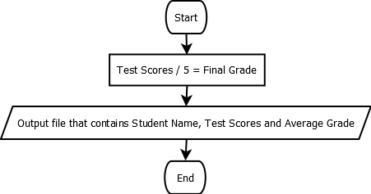

Pseudocode:

import java.util.*;
import java.io.*;

public class Grading{

static Scanner console = new Scanner (System.in);

public static void main(String[]args) throws IOException, FileNotFoundException {
// variable declaration
double Grade;
double Total = 0;
String Name, Surname;

// program will locate file
Scanner inFile = new Scanner(new FileReader("f:\\Grading.txt"));

// program will create a new file
PrintWriter outFile = new PrintWriter ("f:\\Gradingfinal.txt");

// get name
Name = inFile.next();
// get surname
Surname = inFile.next();
// displays Name and Surname
outFile.println ("Student Name: " + Name + " " + Surname);
// displays test scores
outFile.print ("Test Scores: ");

// read the 1st test score
Grade = inFile.nextDouble();
// output the test score
outFile.printf (" %.2f ", Grade);
// update sum
Total = Total + Grade;

// read the 2nd test score
Grade = inFile.nextDouble();
// output the test score
outFile.printf (" %.2f ", Grade);
// update sum
Total = Total + Grade;

// read the 3rd test score
Grade = inFile.nextDouble();
// output the test score
outFile.printf (" %.2f ", Grade);
// update sum
Total = Total + Grade;

// read the 4th test score
Grade = inFile.nextDouble();
// output the test score
outFile.printf (" %.2f ", Grade);
// update sum
Total = Total + Grade;

// read the 5th test score
Grade = inFile.nextDouble();
// output the test score
outFile.printf (" %.2f ", Grade);
// update sum
Total = Total + Grade;

outFile.println();
// program will compute average grade
outFile.printf ("Average Grade: %.2f %n", Total/5.0);

inFile.close();
outFile.close();

}

}

Screenshot:

